# Save Your Analysis to Multiple Excel Worksheets

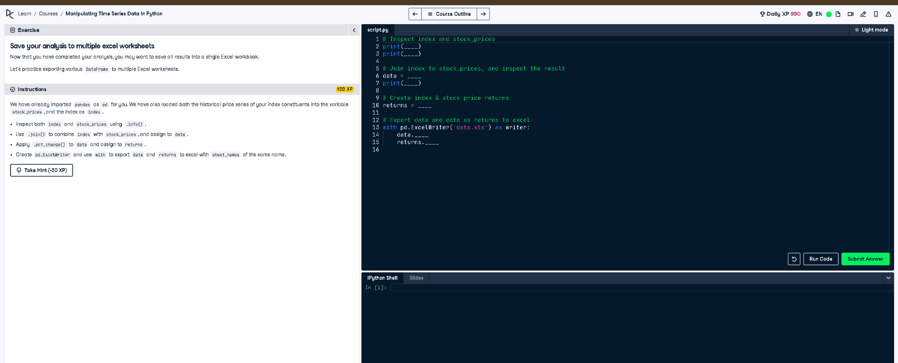

## ✅ Full Correct Answer:

# Inspect index and stock_prices  
print(index.info())  
print(stock_prices.info())  
  
# Join index to stock_prices, and inspect the result  
data = index.join(stock_prices)  
print(data.info())  
  
# Create index & stock price returns  
returns = data.pct_change()  
  
# Export data and returns to Excel  
with pd.ExcelWriter('data.xls') as writer:  
 data.to_excel(writer, sheet_name='data')  
 returns.to_excel(writer, sheet_name='returns')

## 🧾 Explanation (Simple Words):

You start by checking the structure of index and stock_prices. Then, you join them into one DataFrame. You compute daily returns using pct_change() and export both the original and calculated data to Excel. Each is saved in a separate sheet using pandas' ExcelWriter.